Data Structure and Algorithm

Laboratory Activity No. 3

Translating Algorithm to Program

|  |  |
| --- | --- |
| *Submitted by:* | *Instructor:* |
| LastName, FirstName MI. | Engr. Maria Rizette H. Sayo |

Month, DD, YYYY

# Objectives

Introduction

Data structure is a systematic way of organizing and accessing data, and an algorithm is a step-by-step procedure for performing some tasks in a finite amount of time. These concepts are central to computing, but to be able to classify some data structures and algorithms as “good,” we must have precise ways of analyzing them.

This laboratory activity aims to implement the principles and techniques in:

* Writing a well-structured procedure in programming
* Writing algorithm that best suits to solve computing problems
* Writing an efficient Python program from translated algorithms

# Methods

• Design an algorithm and the corresponding flowchart (Note: You may use LucidChart or any application) for adding the test scores as given below if the number is even: 26,49,98,87,62,75

• Translate the algorithm to a Python program (using Google Colab)

• Save your source codes to GitHub

Proceed here for the Algo and the Flow Chart:

<https://drive.google.com/file/d/1Fad_dHYOIdhW0bPMEpWSenas1zCmL2ZQ/view?usp=sharing>

Proceed here for the Source Code:

<https://colab.research.google.com/drive/1lvM9RBn5kAkeJEtkWSw_l2tCV3jO1ZS4?usp=sharing>

# Results

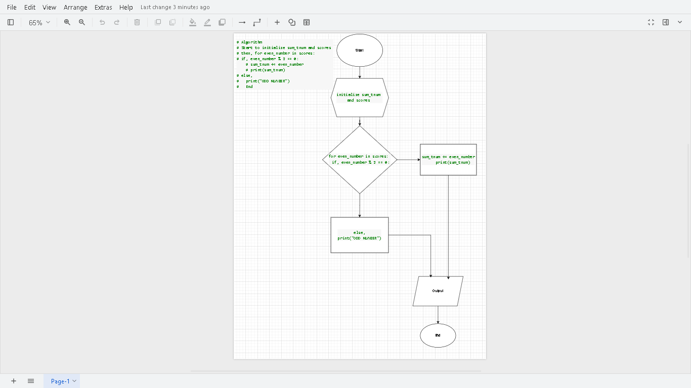

This is the Algo and the Flow Chart I created and if we put it to the source code we will create to variable naming sum_tnum and scores then do a looping with the if so the machine have a decision then if no, else we will print it as ODD NUMBER!!!, until no data in the list.

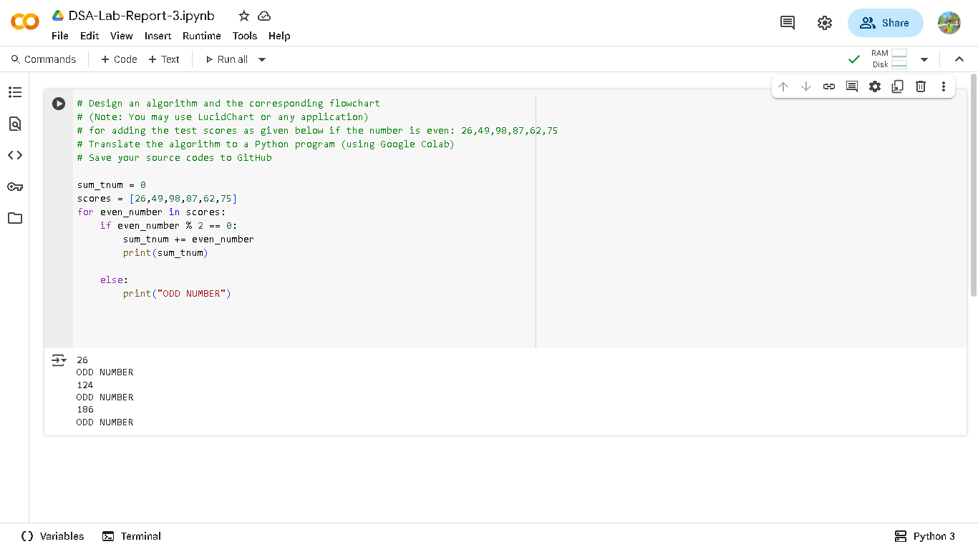

This is the final source code I make and I use for loop combine with some conditonals.

# Conclusion

In conclusion I learn to create some basic function and analyze how I will make an algo and flow chart before coding it’s a good practice to know how will I code and figure e out how I can build the souce code.